OOP Assignment 3
Fall 2022
Note:
- Only zip folder is accepted.
- Create header and implementation file separate (example Student.h, Student.cpp).

Assignment Deadline: Thursday, January 31, 2023, 7:00pm
Submission Procedure:
- Submissions are to be done on Portal in“Assignment 4 Submission Folder”
- Do not submit the DEBUG folder
- Upload a single ZIPPED file (extension either .zip or .rar) containing a folder for each question
- The name of the ZIPPED folder should be the same as your registration number. Example, a student having registration number L1F13BSCS0001 will upload a single file having a name: L1F13BSCS0001.zip or L1F13BSCS0001.rar.
- Each of the folders must only contain the .h and .cpp files related to the questions. Furthermore, each folder must also contain a JPEG file containing the screenshot of the UML diagram.
- The UML diagram must not be automatically generated from Visual Studio.
Scope:
This assignment covers the concepts of Inheritance.
Instructions:
- There should be proper indentation and comments.
- Make your assumptions (but valid) where required but do not forget to mention them.
- Code should meet the mentioned requirements properly.
NOTE: For all the questions, you have to write codes and draw UML diagrams too.

Question 1:
Write a C++ program that implements the given class hierarchy (access specifiers are hidden for students to think about what these should be).
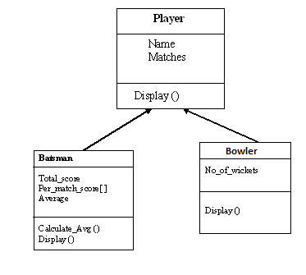
Your program should consist of three classes
- Player
This class contains two data members
- Name //for player’s name
- Matches //for number of matches player played

The Player class should contain a member function named Display() which is meant to display the data members values on the screen.
- Batsman
This class should contain the following data members
  - Total_score //for total scores a Batsman scored
  - Per_match_score[ ] //for per match score, the array size should equal to the number of matches a Batsman/Player played
  - Average //for score’s average

This class should also contain two member functions. One of which named Calculate_Avg () which is meant to calculate average scores of batsman. It should also contain another member function named Display() which is meant to display the information of Batsman. Before displaying the data members of Batsman, it should display the data members of Player.
- Bowler
This class should contain the following data member
- No_of_wickets //for total number of wickets a baller have taken

This class should also contains a member function named Display() which is meant to display the information of Baller. Before displaying the data members of Baller, it should display the data members of Player.
Question 2:
A university community has thousands of members. These members consist of employees, students and alumni. Employees are either faculty members or staff members. Faculty members are either administrators (such as deans and department chairpersons) or teachers. Some administrators, however, also teach classes. Note that we have used multiple inheritance to form class AdministratorTeacher. Also note that this inheritance hierarchy could contain many other classes. For example, students can be graduate or undergraduate students. Undergraduate students can be freshmen, sophomores, juniors and seniors. The inheritance hierarchy is shown below:
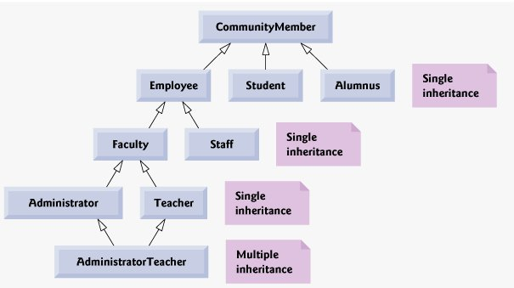

Code the hierarchy shown above adding appropriate attributes/member functions/member variables and extent the hierarchy from the Student class. Use Student as the base class of the hierarchy, then include classes UndergraduateStudent and GraduateStudent that derive from Student. Continue to extend the hierarchy as deep (i.e., as many levels) as possible. For example, Freshman, Sophomore, Junior and Senior might derive from UndergraduateStudent, and DoctoralStudent and MastersStudent might derive from GraduateStudent. After drawing the hierarchy, create an object of each class in the main function and call at least one function inherited in it.

Question 3:
The world of shapes is much richer than the shapes included in the inheritance hierarchy shown below:
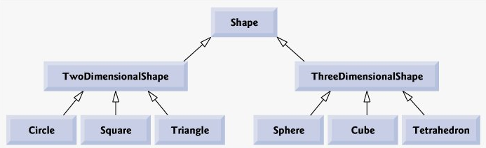
Write down all the shapes you can think of both two-dimensional and three-dimensional and form them into a more complete Shape hierarchy with as many levels as possible. Your hierarchy should have base class Shape from which class TwoDimensionalShape and class ThreeDimensionalShape are derived. Provide an area function and a volume function in the base class Shape. Override these functions in the derived classes if required. Make an object of each of the child class (which is present at the lowest level of inheritance) and call the area function for 2D shapes and volume function for 3D shapes using these objects.

Question 4:
In the lecture, we solved the diamond problem using the class an all-rounder. It was stated that: an all-rounder is both batsman and a bowler; both batsman and bowler are cricketers. Hence the inheritance hierarchy took the following shape:
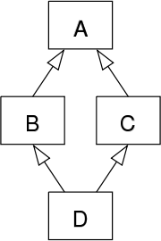
Your task is to come up with a real-life example which satisfies the inheritance hierarchy of the diamond problem. One such example could be: “A Teaching Assistant is an employee and a student. Both employee and student are persons”. The inheritance hierarchy for this statement would be:
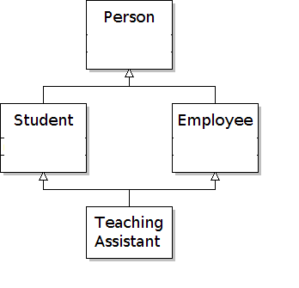
Come up with one such real-life example. Clearly mention the problem statement of your chosen scenario on the top of the UML diagram. Code the real-life scenario with proper class attributes and member functions. Also, note that you cannot implement the all-rounder and the teaching assistant example now.

